**HOW TO FETCH LOGS**

Step 1:

Logonto the 02 server

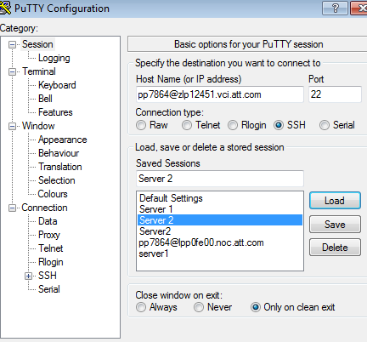

Step 2: Login to NC3

sudo su - nc3

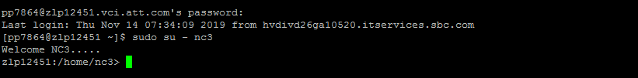

Step 3:

Fetch the logs using the below command

$ ./logscan. ISR19112515339-0001 201911*

Send XML for ISR19112515339-0001 -- File: nc3xapi20191126-8051.log

2019-11-26 17:01:34 [P9764/T2976] ApplID=123<?xml version="1.0" encoding="UTF-8" ?><APIInterface xmlns="http://nc3pc4.sch.advantis.com/XMLSchema/API" xmlns:xsi="http://

www.w3.org/2001/XMLSchema-instance" xsi:schemaLocation="http://nc3pc4.sch.advantis.com/XMLSchema/API ./NC3API.xsd"><DiscoComponent><RequestingApplication>USRP</Requesti

ngApplication> <OrderNumber>ISR19112515339-0001</OrderNumber> <SearchByFieldname>ODBID</SearchByFieldname> <ComponentType>Equipment</ComponentType> <ComponentKey>246260

661</ComponentKey> <RemoveCircuitEquipment>Y</RemoveCircuitEquipment> </DiscoComponent></APIInterface>

\n

Return XML for ISR19112515339-0001 -- File: nc3xapi20191126-8051.log

2019-11-26 17:01:36 [P9764/T2976] ApplID=123<?xml version='1.0' encoding='UTF-8'?><!--XML file generated by APIMAIN program--><APIInterface xmlns='http://nc3pc4.sch.adv

antis.com/XMLSchema/API' xmlns:xsi='http://www.w3.org/2001/XMLSchema-instance' xsi:schemaLocation='http://nc3pc4.sch.advantis.com/XMLSchema/API ./NC3API.xsd'><DiscoComp

onentResponse><ReturnCode>NCC0115:</ReturnCode><ReturnMessageList><ReturnMessageListItem><ReturnMessage>NCC0115: Audit Error. Error text: NCC0001: The version's start d

ate can not be later than the version's stop date (Object Type: Connection ODBID 291004260)..</ReturnMessage></ReturnMessageListItem></ReturnMessageList></DiscoComponen

tResponse></APIInterface>

If we do not get the logs for recent month then we can check previous three month logs

(201510* 201509* 201508*)

Also If we dont find logs using logscan command then we need to run grep command

-----------------------------------------------------

$ apixml then

cd /opt/nc3/current/logs/apixml

grep order number *



**Web service logs:**

cd /opt/nc3/current/logs/javaserv/ws/CAMOService-Server ------For checking CAMO Service Logs ,SMOD

cd /opt/nc3/current/logs/javaserv/ws/AssetTransferService-Client -----partstopick logs

cd /opt/nc3/current/logs/javaserv/ws/WarehouseService-Server ----- For checking assets

cd /opt/nc3/current/logs/javaserv/ws/LoadEOLServices-Server -------For Checking EOL Load error

cd /opt/nc3/current/logs/javaserv/ws/NotifyCPEWorkflowEvent-Client -----To Check Notification Logs